11.75: a)
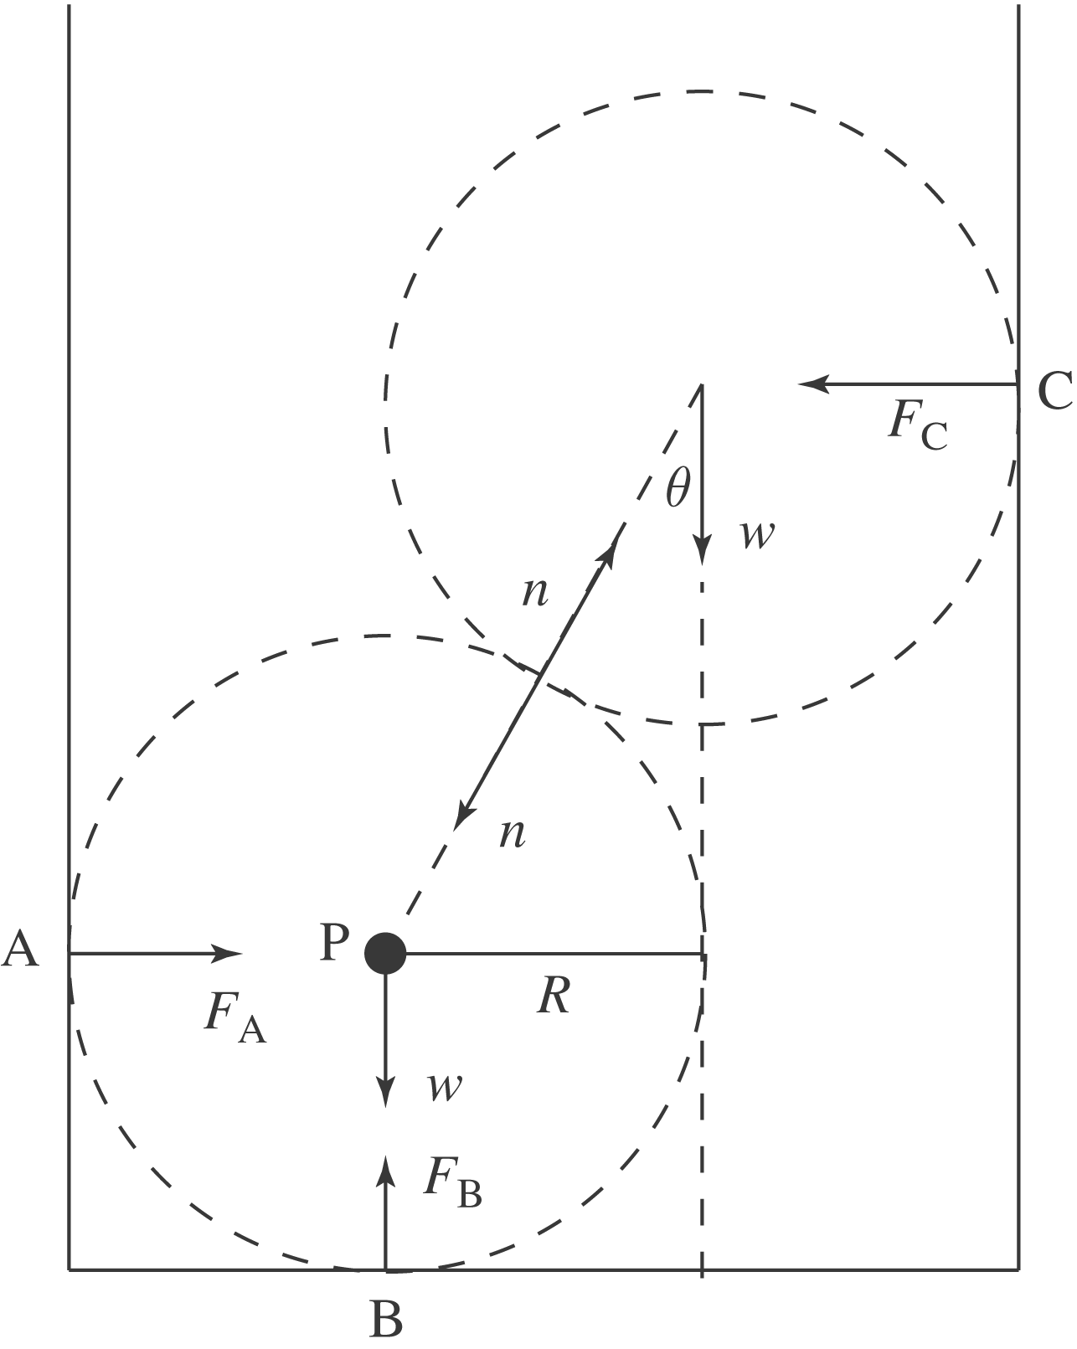
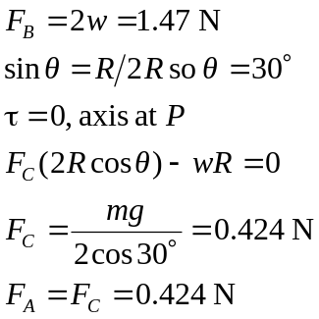
b) Consider the forces on the bottom marble. The horizontal forces must sum to zero, so
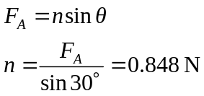
Could use instead that the vertical forces sum to zero
